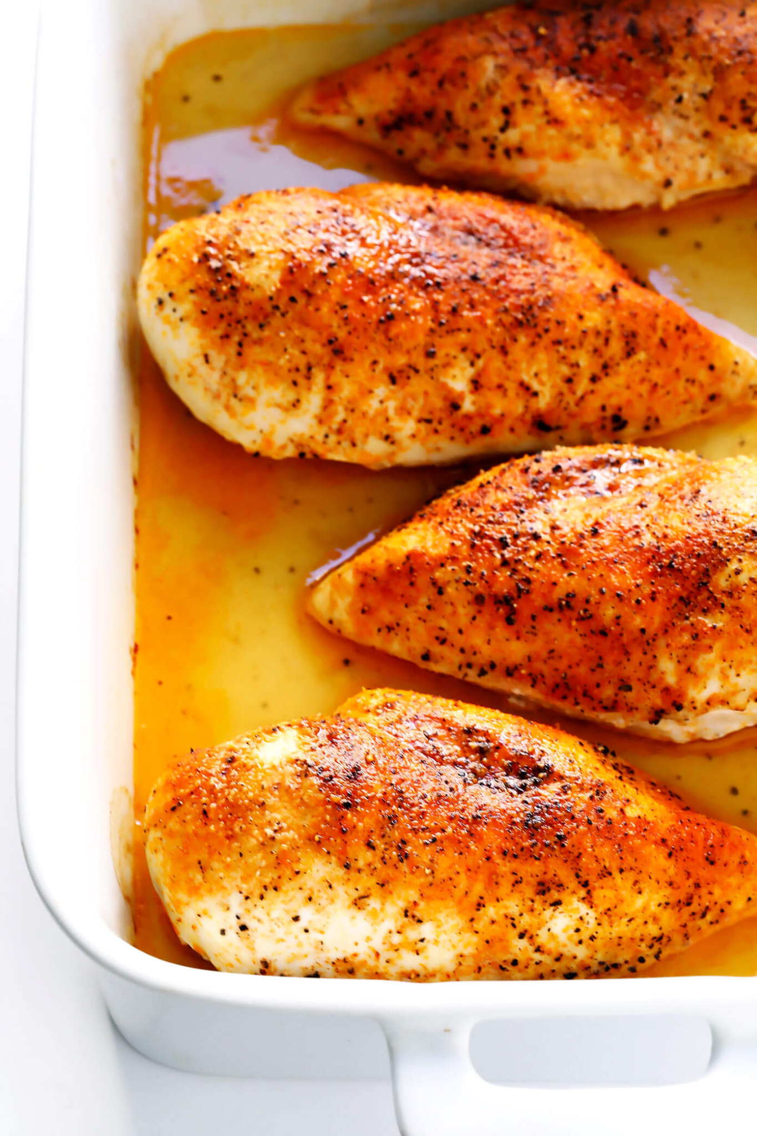

***Oven roasted Chicken Recipe 1***

### **Ingredients**

* ▢
* 4 chicken breasts *, 150 - 180g / 5 - 6 oz each (Note 1)*
* ▢
* 2 tsp olive oil

#### **SEASONING:**

* ▢
* 1 1/2 tbsp brown sugar
* ▢
* 1 tsp paprika
* ▢
* 1 tsp dried oregano or thyme *, or other herb of choice*
* ▢
* 1/4 tsp garlic powder
* ▢
* 1/2 tsp each salt and pepper

#### **GARNISH, OPTIONAL:**

* ▢
* Finely chopped parsley

### **Instructions**

1. Preheat oven to 425°F/220°C (200°C fan).
2. Pound chicken to 1.5cm / 0.6" at the thickest part - using a rolling pin, meat mallet or even your fist (key tip for even cooking + tender chicken).
3. Mix Seasoning.
4. Line tray with foil and baking / parchment paper. Place chicken upside down on tray. Drizzle chicken with about 1 tsp oil. Rub over with fingers. Sprinkle with Seasoning.
5. Flip chicken. Drizzle with 1 tsp oil, rub with fingers, sprinkle with Seasoning, covering as much of the surface area as you can.
6. Bake 18 minutes, or until surface is golden per photos and video, or internal temperature is 165°F/75°C using a meat thermometer.
7. Remove from oven and immediately transfer chicken to serving plates.
8. Wait 3 - 5 minutes before serving, garnished with freshly chopped parsley if desired.

***Oven Roasted Chicken Recipe 2***

### **DESCRIPTION**

Learn how to make juicy, tender, delicious baked chicken breasts with this simple 5-step method.

### **INGREDIENTS**

#### **BAKED CHICKEN BREAST INGREDIENTS:**

* 4 boneless skinless chicken breasts, pounded to even thickness and brined in saltwater (*see easy instructions below)
* 1 Tablespoon melted butter or olive oil
* 1 teaspoon kosher salt
* 1/2 teaspoon freshly-cracked black pepper
* 1/2 teaspoon garlic powder
* 1/2 teaspoon paprika (I prefer smoked paprika)

### **INSTRUCTIONS**

* **Brine the chicken.** To brine your chicken breasts, fill a large bowl with 1 quart of warm water and 1/4 cup kosher salt. Stir to combine until most of the salt is absorbed. Add the chicken breasts and let them sit in the mixture to brine for 15 minutes. Or you can also also cover the bowl and refrigerate for up to 6 hours. Remove the chicken breasts from the brine, rinse them with cold water, then pat them dry with some paper towels. *(However, if the chicken breasts you purchased have already been pre-brined in a sodium solution, skip this step.)*
* **Heat the oven.** Preheat oven to 450°F.
* **Season the chicken.** Place the chicken breasts in a single layer in a large baking dish*. Brush on both sides (turning once) evenly with the melted butter or olive oil. In a separate small bowl, whisk the salt, pepper, garlic powder and paprika until combined. Then sprinkle the mixture evenly over the chicken on both sides.
* **Bake.** Bake for 15-18* minutes, or until the chicken is cooked through and no longer pink. Cooking time will depend on the thickness of the chicken breasts, so I recommend using a cooking thermometer to know exactly when it is fully cooked. The thickest part of the breast, it should be 165°F. *(Or, if you want the chicken to be a little bit browned and crispier on top, you can turn the broiler on high for the final 3-5 minutes and broil the chicken until it is cooked through and golden on top. Keep a close eye on the chicken so that it does not overcook and/or burn.)*
* **Rest the chicken.** Once the chicken is cooked, remove the pan from the oven, transfer the chicken to a clean plate, and loosely tent the plate with aluminum foil. Let the chicken rest for at least 5-10 minutes.
* **Serve.** Serve warm. Or, refrigerate in a sealed container for up to 3 days, or freeze for up to 3 months.

***Oven Roasted Chicken Recipe 3***

How to make the absolute best juicy baked chicken breast in the oven. Easy to customize with your favorite seasoning, healthy, and so tender!

### **Ingredients**

* 3 to 4 boneless, skinless chicken breasts *(about 1 1/2 pounds)*
* Wet or dry brine *see below*
* 2 to 4 teaspoons [extra virgin olive oil](https://amzn.to/34bAz5D) *1 teaspoon per breast*
* 1 teaspoon paprika*
* 1 teaspoon garlic powder*
* 1/2 teaspoon kosher salt *add ONLY if rinsing the chicken, plus additional to taste*
* 1/4 teaspoon ground black pepper*
* Additional seasonings of choice *see blog post above for suggestions*

#### **FOR A DRY BRINE:**

* 1 to 2 teaspoons kosher salt

#### **FOR A WET BRINE:**

* 4 cups warm water
* ¼ cup kosher salt

### **Instructions**

### 

* Place chicken breasts on a cutting board and lay a large piece of plastic wrap over the top to guard against splatters. With a meat mallet or rolling pin, pound the breasts into an even thickness.
* Pat the chicken breasts dry on both sides.
* TO DRY BRINE: Sprinkle the breasts generously on both sides with salt. Place in the refrigerator uncovered for 30 minutes or up to 1 day.
* TO WET BRINE: In a large bowl, stir together the warm water and salt. Place the chicken breasts in the water and let sit at room temperature for 15 minutes, or cover and refrigerate for up to 4 hours.
* TO COOK: Preheat the oven to 425 degrees F. If the chicken is in the refrigerator, remove it. If dry brining, with a paper towel, wipe off the salt well from both sides (I do not rinse my dry brine). If wet brining, remove the chicken from the wet brine and rinse it off (to skip the rinse, omit any remaining salt from the recipe; your chicken will be salty but by no means inedible).
* Pat the chicken very dry on both sides, wiping away any clearly visible salt. If the chicken has been in the refrigerator, let it sit at room temperature for 10 minutes.
* Coat a ceramic or metal baking dish large enough to hold the chicken in a single layer (such as a 9×13-inch baking dish) with nonstick spray. (I do not recommend using glass/Pyrex, as the way it conducts heat will not cook the chicken as evenly. If needed, you can bake the chicken on a metal baking sheet.)
* Place the chicken in a large bowl (if wet brining, rinse out, dry, and reuse the same bowl if you like). Add the olive oil, paprika, garlic powder, salt (only add the salt if you rinsed your chicken), and pepper. Toss to coat the chicken evenly, then arrange it in the baking dish.
* Bake the chicken for 14 to 16 minutes (for small/medium breasts that are about 6 to 7 ounces), 16 to 20 minutes (for medium/large breasts that are 8 to 10 ounces), or 20 to 25 minutes (for larger breasts). For absolute best results, use an instant read thermometer. When the breasts reach 165 degrees F, they are done.
* REST: Transfer the chicken to a plate or cutting board. Cover and let rest for a minimum of 5 minutes. Slice, dice, or shred as desired. Enjoy!

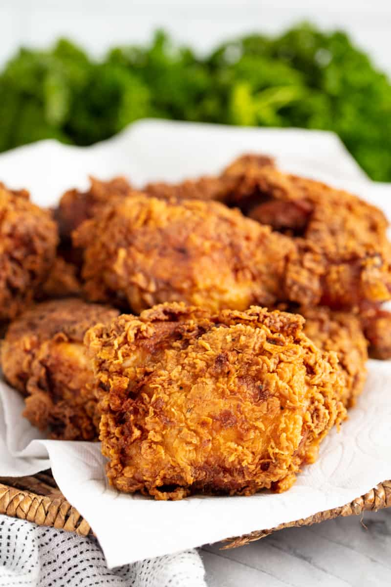

***Fried Chicken Recipe***

***INGREDIENTS***

* ***6 chicken thighs***
* ***6 chicken drumsticks***
* ***3 cups buttermilk***
* ***1/2 cup Buffalo Hot Sauce optional***
* ***2 teaspoons salt***
* ***1 teaspoon pepper***

#### ***Dredging Mixture***

* ***3 cups all-purpose flour***
* ***1/2 cup cornstarch***
* ***1 tablespoon salt***
* ***1 tablespoon paprika***
* ***2 teaspoons onion powder***
* ***2 teaspoons garlic powder***
* ***1 teaspoon dried oregano***
* ***1 teaspoon dried basil***
* ***1 teaspoon white pepper***
* ***1 teaspoon cayenne pepper***
* ***1 quart vegetable oil for frying***

***INSTRUCTIONS***

1. ***In a large mixing bowl, whisk together buttermilk, hot sauce (optional, for added flavor), salt, and pepper in a mixing bowl. Add in chicken pieces. Cover the bowl with plastic wrap and refrigerate 4 hours.***
2. ***When ready to cook, pour the vegetable oil in a skillet until it is about 3/4 inch deep. Heat to 350 degrees.***
3. ***Prepare the breading by combining the flour, cornstarch, onion powder, garlic powder, oregano, basil, white pepper, cayenne pepper, paprika, and salt in a gallon sized resealable plastic bag or shallow dish. Mix it thoroughly.***
4. ***Working one at a time, remove chicken pieces from buttermilk mixture. Shake it gently to remove the excess. Place it in the breading mix and coat thoroughly. Tap off the excess.***
5. ***Place the breaded chicken into the 350 degree oil. Fry 3 or 4 pieces at a time. The chicken will drop the temperature of the oil so keep it as close to 350 degrees as possible. Fry each piece for 14 minutes, turning each piece about half way through, until the chicken reaches an internal temperature of 165 degrees F.***
6. ***Remove from the oil and place on paper towels. Let them rest for at least 10 minutes before serving.***

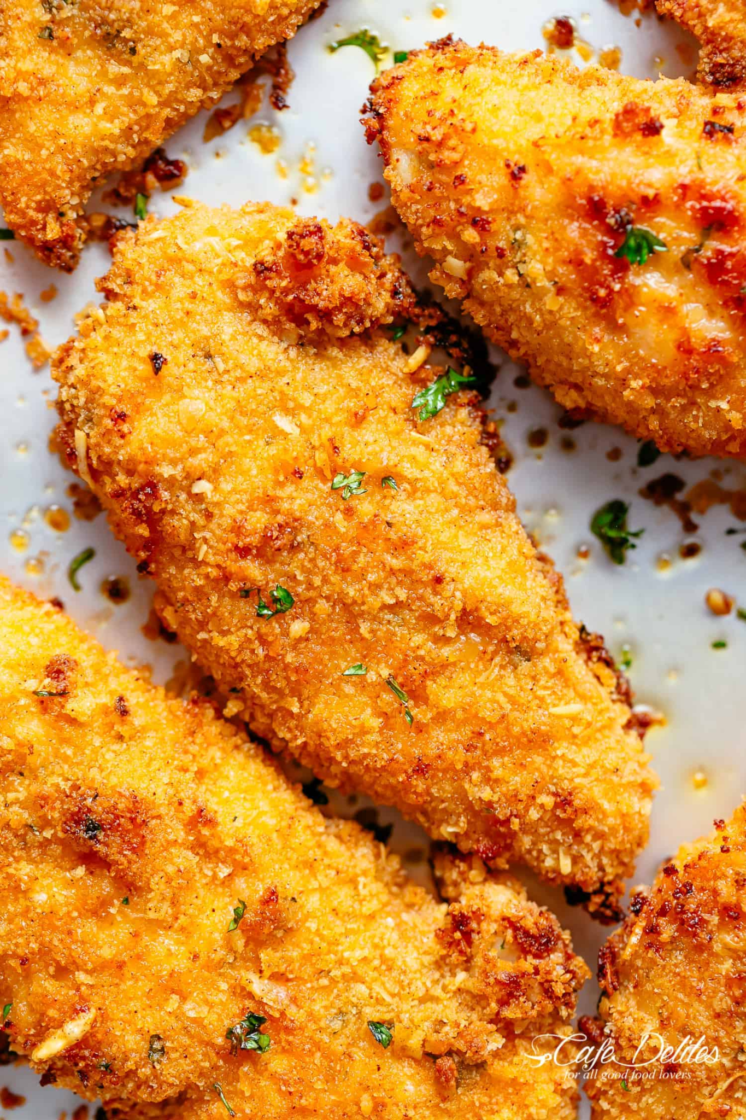

***Chicken Tenders Recipe***

### *INGREDIENTS*

* ***1 large egg***
* ***2 tablespoons olive oil***
* ***2 tablespoons lemon juice (or juice of 1/2 a lemon)***
* ***1 tablespoon fresh chopped parsley***
* ***2 teaspoons minced garlic***
* ***3/4 teaspoon salt to season***
* ***1/4 teaspoon cracked black pepper***
* ***28 ounces (800 g) chicken tenders***
* ***1 cup Panko breadcrumbs***
* ***1/2 cup regular breadcrumbs (garlic, herb or Italian seasoned for extra flavour)***
* ***1 teaspoon mild paprika (or sweet, smoky, spicy)***
* ***1/2 teaspoon garlic powder***
* ***1/2 teaspoon onion powder***
* ***1/4 cup fresh grated parmesan cheese***

### *INSTRUCTIONS*

1. ***Preheat oven to 400°F (200°C). Lightly grease a baking tray / sheet with cooking oil spray, or a light coating of oil. Set aside.***
2. ***In a large bowl, whisk together the egg, oil, lemon juice, parsley, garlic, salt and pepper.***
3. ***Dip chicken tenders into egg mixture and let sit for 5 minutes while preparing crumb mixture.***
4. ***OPTIONAL: Cover and allow to marinate in the refrigerator for 30 minutes to an hour (if time allows).\****
5. ***In another bowl, combine both breadcrumbs, paprika, garlic powder, onion powder and parmesan cheese.***
6. ***Dredge the egg coated chicken in the breadcrumb/parmesan mixture, lightly pressing to evenly coat.***
7. ***Arrange tenders on the baking sheet / tray and lightly spray with cooking oil spray.***
8. ***Bake for 10 minutes. Flip and bake for a further 5-10 minutes or until cooked through. (Broil in the last 2-3 minutes for a golden crispy crumb!)***

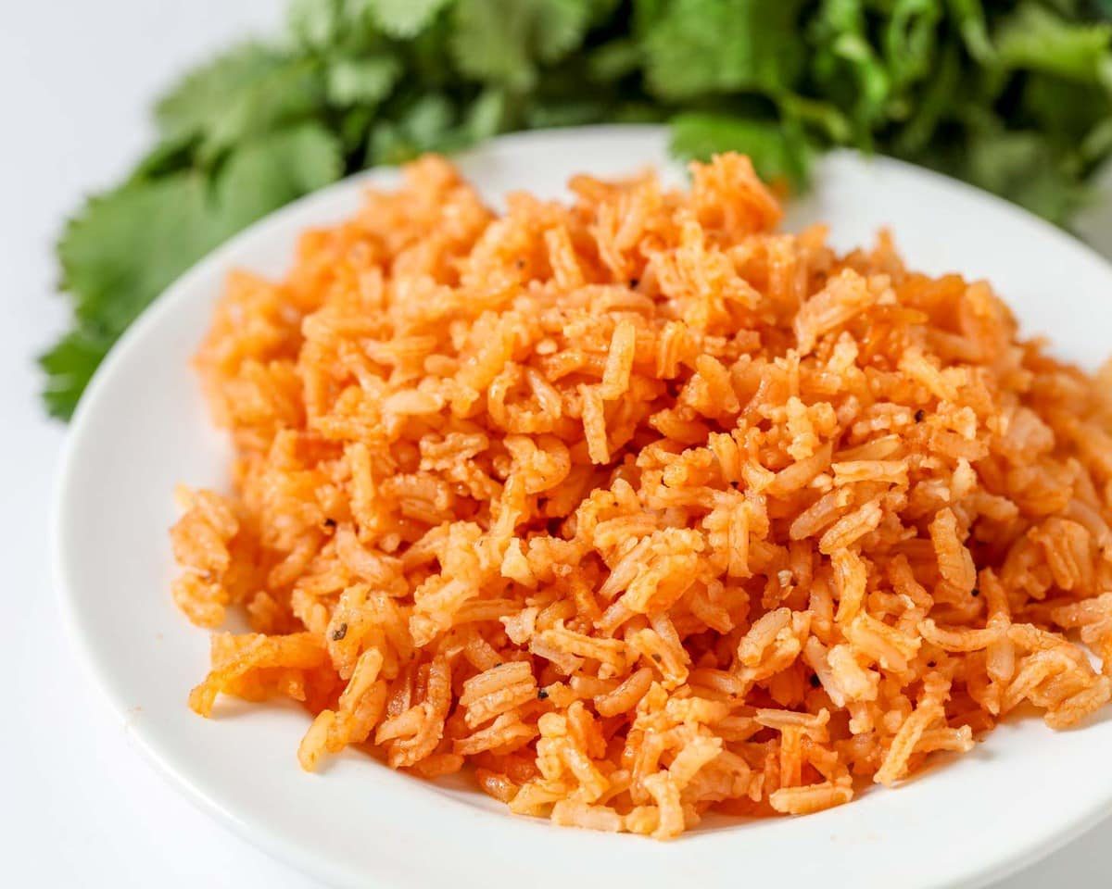

***Spanish Rice Recipe 1***

### **Ingredients**

* 2 cups long grain rice
* 1/8 cup oil
* 8 oz tomato sauce
* 6 stems cilantro (optional)
* 1 tsp [salt](https://amzn.to/3C05p0i)
* 1 tsp minced garlic
* 4 cups water (or 4 cups chicken lower sodium chicken broth - and no bouillon)
* 1 cube chicken flavored bouillon
* dash cumin
* dash garlic pepper

### **Instructions**

### 

1. Heat oil in large frying pan on medium heat.
2. Add rice and cook until golden brown.
3. Add 1 chicken flavored bouillon cube to 4 cups water and microwave for 3 minutes.
4. When rice is brown, add water, tomato sauce, salt, garlic, cumin and garlic pepper to pan.
5. Stir and cover pan. Let simmer for 30-40 minutes or until all is cooked and there is no liquid left. Fluff before serving and ENJOY.

***Spanish Rice Recipe 2***

### **Ingredients**

* ▢
* 1 1/2 cups long grain white rice *
* ▢
* 1/4 cup oil (vegetable or canola oil)
* ▢
* 1 teaspoon garlic , minced
* ▢
* 1/4 medium onion , finely diced
* ▢
* 1/4 cup tomato sauce , or 2 pureed tomatoes*
* ▢
* 2 teaspoons [tomato bouillon](https://amzn.to/3tlzfYJ) granulated, or cubes*
* ▢
* 1/4 teaspoon salt
* ▢
* 1 carrot , diced
* ▢
* 1/2 cup peas (frozen or fresh)
* ▢
* 3 cups water
* ▢
* 1-3 whole serrano peppers , optional

### **Instructions**

### 

1. Rinse the rice in a fine mesh strainer until the water runs clear. Set aside.
2. In a large saucepan over medium-high heat, add the oil. Once hot, add the rice and stir to combine. Cook over medium heat, stirring frequently, until the rice is lightly golden brown all over (about 10 minutes).
3. Add tomato sauce, garlic, and diced onion to the pan. Stir. Add tomato bullion, salt, carrots, peas, and water (and serrano peppers, if using. They add a little flavor, but not spice.).
4. Bring to a boil, then cover, reduce heat to low and cook for about 20 minutes or until the water is completely absorbed. Remove from heat and allow to rest for 5 minutes before fluffing with a fork.

***Spanish Rice Recipe 3***

### **INGREDIENTS:**

* 1 tablespoon olive oil
* 2 cloves garlic, minced
* 1 onion, diced
* 1 1/2 cups basmati rice
* 1 (8-ounce) can tomato sauce
* 1 1/2 cups vegetable broth
* 1 cup corn kernels
* 1/2 cup diced carrots
* 1/2 cup frozen peas
* 1/4 teaspoon chili powder
* 1/4 teaspoon cumin
* Kosher salt and freshly ground black pepper, to taste
* 2 Roma tomatoes, diced
* 2 tablespoons chopped fresh cilantro leaves

### **DIRECTIONS:**

1. Heat olive oil in a large skillet over medium heat. Add garlic and onion, and cook, stirring frequently, until onions have become translucent, about 2-3 minutes. Stir in rice until toasted, about 2 minutes.
2. Stir in tomato sauce and vegetable broth, and bring to a simmer, about 2 minutes. Stir in corn, carrots, peas, chili powder and cumin; season with salt and pepper, to taste. Bring to a boil; cover, reduce heat and simmer until rice is cooked through, about 13-16 minutes. Stir in tomatoes.
3. Serve immediately, garnished with cilantro, if desired.

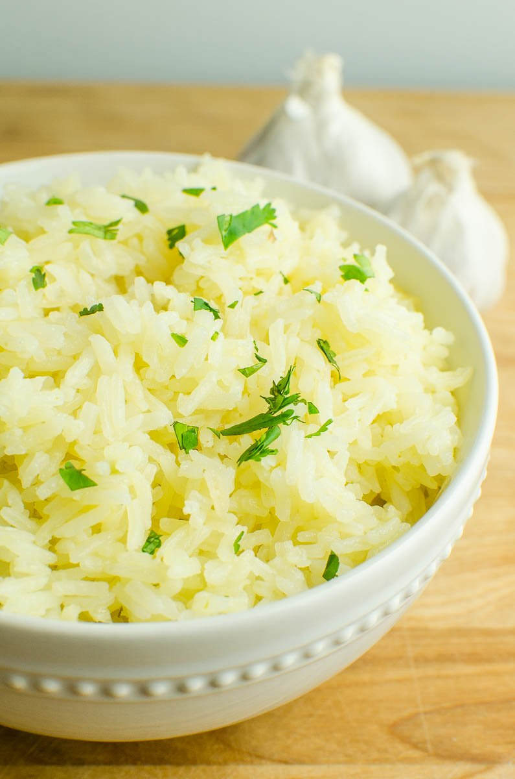

***Garlic Butter Rice***

### *INGREDIENTS*

#### *Ingredients:*

* ***1 tablespoon butter***
* ***1 tablespoon olive oil***
* ***4 cloves garlic sliced***
* ***1 cup uncooked jasmine rice***
* ***2 cups chicken broth***
* ***chopped fresh parsley***

### *INSTRUCTIONS*

### 

* ***In a saucepan over medium heat combine butter and olive oil. Once butter has melted add garlic and cook one minute.***
* ***Stir in rice, cook until rice becomes slightly translucent. Stirring occasionally to make sure rice doesn’t stick to the bottom of the pan. About 4 minutes. Rice may brown slightly.***
* ***Stir in chicken broth, bring to a boil. Reduce heat to medium-low. Cover and let cook 20-25 minutes.***
* ***Carefully remove lid, fluff rice with a fork and sprinkle with chopped parsley.***
* ***Serve.***

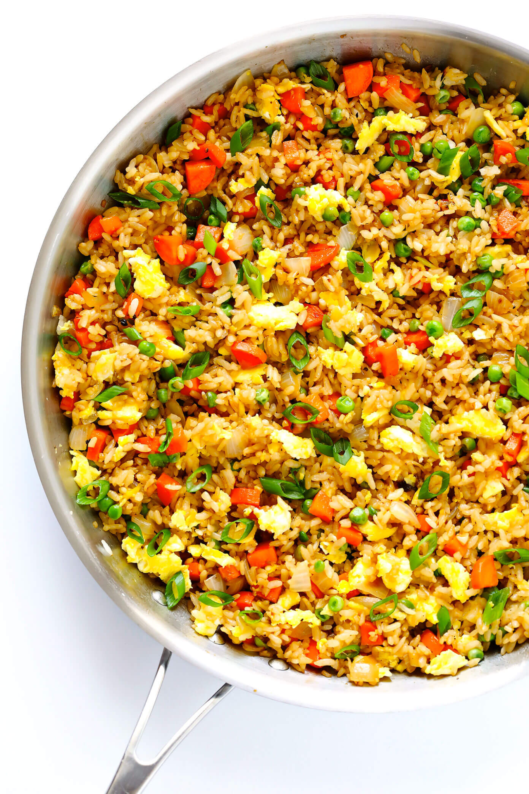

***Fried Rice Recipe***

### ***INGREDIENTS***

* ***3 tablespoons butter, divided***
* ***2 eggs, whisked***
* ***2 medium carrots, peeled and diced***
* ***1 small white onion, diced***
* ***1/2 cup frozen peas***
* ***3 cloves garlic, minced***
* ***salt and black pepper***
* ***4 cups cooked and chilled rice (I prefer short-grain white rice)***
* ***3 green onions, thinly sliced***
* ***3–4 tablespoons soy sauce, or more to taste***
* ***2 teaspoons oyster sauce (optional)***
* ***1/2 teaspoons toasted sesame oil***

### ***INSTRUCTIONS***

* ***Heat 1/2 tablespoon of butter in a large sauté pan* over medium-high heat until melted. Add egg, and cook until scrambled, stirring occasionally. Remove egg, and transfer to a separate plate.***
* ***Add an additional 1 tablespoon butter to the pan and heat until melted. Add carrots, onion, peas and garlic, and season with a generous pinch of salt and pepper. Sauté for about 5 minutes or until the onion and carrots are soft. Increase heat to high, add in the remaining 1 1/2 tablespoons of butter, and stir until melted. Immediately add the rice, green onions, soy sauce and oyster sauce (if using), and stir until combined. Continue sautéing for an additional 3 minutes to fry the rice, stirring occasionally. (I like to let the rice rest for a bit between stirs so that it can crisp up on the bottom.) Then add in the eggs and stir to combine. Remove from heat, and stir in the sesame oil until combined. Taste and season with extra soy sauce, if needed.***
* ***Serve immediately, or refrigerate in a sealed container for up to 3 days.***

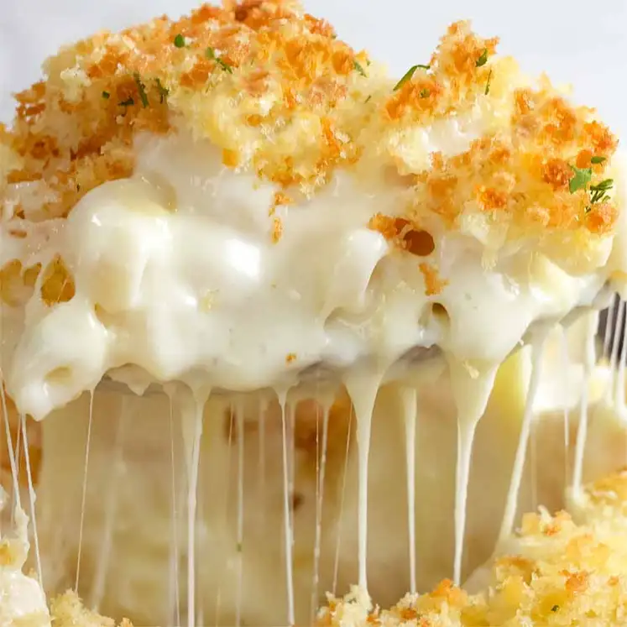

***Mac and Cheese Recipe 1***

## **Ingredients**

* 8 ounces uncooked elbow macaroni
* 2 cups shredded sharp Cheddar cheese
* ½ cup grated Parmesan cheese
* 3 cups milk
* ¼ cup butter
* 2 ½ tablespoons all-purpose flour
* 2 tablespoons butter
* ½ cup bread crumbs
* 1 pinch paprika

**Directions**

Instructions Checklist

* **Step 1**Cook macaroni according to the package directions. Drain.
* **Step 2**In a saucepan, melt butter or margarine over medium heat. Stir in enough flour to make a roux. Add milk to roux slowly, stirring constantly. Stir in cheeses, and cook over low heat until cheese is melted and the sauce is a little thick. Put macaroni in large casserole dish, and pour sauce over macaroni. Stir well.
* **Step 3**Melt butter or margarine in a skillet over medium heat. Add breadcrumbs and brown. Spread over the macaroni and cheese to cover. Sprinkle with a little paprika.
* **Step 4**Bake at 350 degrees F (175 degrees C) for 30 minutes. Serve.

***Mac and Cheese Recipe 2***

### ***Ingredients***

#### ***MACARONI:***

* ***▢***
* ***250g / 8 oz macaroni (elbow pasta)***
* ***▢***
* ***1 tbsp (15g) unsalted butter (or 2 tsp oil)***

#### ***TOPPING:***

* ***▢***
* ***2/3 cup panko breadcrumbs (Note 1)***
* ***▢***
* ***2 tbsp (30g) unsalted butter , melted***
* ***▢***
* ***1/4 tsp salt***

#### ***SAUCE:***

* ***▢***
* ***4 tbsp (60g) unsalted butter***
* ***▢***
* ***1/3 cup flour , plain / all purpose***
* ***▢***
* ***3 cups milk , warmed (low or full fat)***
* ***▢***
* ***2 cups freshly shredded cheese, gruyere best (followed by cheddar and Colby) (Note 2)***
* ***▢***
* ***1 cup freshly shredded mozzarella cheese , or more other cheese of choice (Note 2)***
* ***▢***
* ***3/4 tsp salt***

#### ***SEASONINGS (OPTIONAL):***

* ***▢***
* ***1 tsp garlic powder***
* ***▢***
* ***1/2 tsp onion powder***
* ***▢***
* ***1/2 tsp mustard powder***

### ***Instructions***

#### ***PASTA:***

1. ***Cook pasta: Bring a large pot of water to the boil. Add macaroni and cook per packet directions MINUS 1 minute.***
2. ***Toss in butter: Drain, return pasta to pot, add butter and toss until melted. Set aside to cool while making the Sauce (Optional – Note 3).***

#### ***TOPPING:***

1. ***Mix together Topping. Set aside.***

#### ***SAUCE :***

1. ***Preheat oven to 180°C/350°F (all oven types).***
2. ***Make roux: In a large saucepan or in an ovenproof skillet (I use my 26cm/9" Lodge cast iron skillet), melt butter over medium heat. Add flour and cook, stirring constantly, for 1 minute.***
3. ***Add milk: Add about 1 cup of the milk and mix to dissolve the paste into the milk. Then add remaining milk and mix until lump free (use whisk if required).***
4. ***Add Seasonings: Mix in salt and Seasonings if using.***
5. ***Thicken sauce: Cook, stirring/whisking regularly, for 5 – 8 minutes until thickened to a cream consistency. When the Sauce coats the back of a wooden spoon, you should be able to draw a path with your finger.***
6. ***Add cheese: Remove from stove, add cheese and stir – cheese doesn't need to melt.***
7. ***Check salt: Adjust salt to taste (if you use recommended cheeses, you won't need more).***

#### ***ASSEMBLING:***

1. ***Assemble: Pour Sauce into pot with Macaroni. Stir quickly, then pour back into the skillet (I did this) or a baking dish (Note 4). Sprinkle with breadcrumb topping.***
2. ***Bake for 25 minutes or until top is light golden. Don't bake too long otherwise you'll bake away the Sauce!***
3. ***Serve: Serve immediately! I sprinkled mine with a bit of fresh parsley. See notes for best make-ahead method.***

***Mac and Cheese Recipe 3***

### ***Ingredients***

* ***½ lb uncooked elbow macaroni , about 1 ½ cups***
* ***▢***
* ***3 tablespoons butter***
* ***▢***
* ***2 tablespoons all-purpose flour***
* ***▢***
* ***1/2 teaspoon salt***
* ***▢***
* ***1/8 teaspoon ground black pepper***
* ***▢***
* ***1 1/2 cup milk , any kind***
* ***▢***
* ***3/4 cup half and half***
* ***▢***
* ***2 1/2 cups shredded cheddar cheese \****

### ***Instructions***

### 

1. ***Preheat the oven to 325 degrees and lightly grease a square baking dish.***
2. ***Cook the macaroni to al dente, according to package instructions. Drain and set aside.***
3. ***Melt the butter in a medium saucepan over medium heat. Blend in the flour, salt, and pepper. Cook for 2 minutes.***
4. ***Slowly add the milk and half and half, stirring constantly, and cook over medium-low heat for a few minutes until the mixture is just barely thickened. Remove from heat and stir in 1 cup shredded cheese, stirring just until melted.***
5. ***Add the cooked macaroni noodles and toss to coat. Pour half or the pasta mixture into the prepared baking dish. Sprinkle ½ cup cheese over the top. Add remaining pasta and sprinkle with remaining cheese.***
6. ***Bake for 15-20 minutes or until cheese is melted on top.***
7. ***Serve with your favorite vegetable or a side salad.***

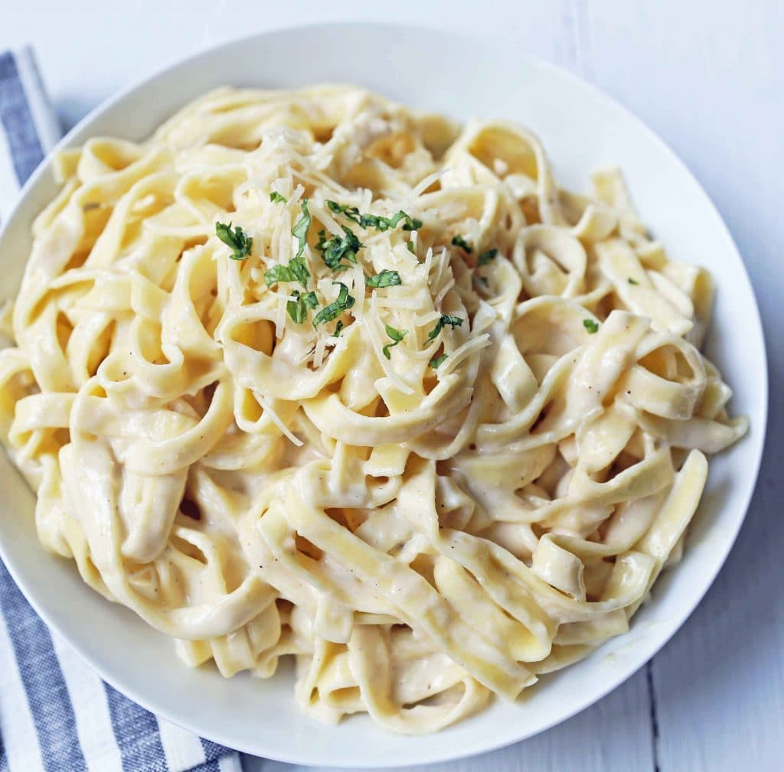

***Fettuccine Alfredo Recipe***

***Ingredients***

* ***1 lb Fettuccine Pasta***
* ***6 Tablespoons Butter***
* ***1 Garlic Clove (minced)***
* ***1 1/2 cups Heavy Cream***
* ***1/4 teaspoon Salt***
* ***1 1/4 cup Shredded Parmesan Cheese***
* ***1/4 teaspoon Pepper***
* ***2 Tablespoons Italian Parsley (optional)***

***Instructions***

* ***In a large pot, heat water over high heat until boiling. Add salt to season the water. Once it is boiling, add fettuccine and cook according to package instructions.***
* ***In a large skillet or pan, heat butter over medium heat. Add minced garlic and cook for 1 to 2 minutes. Stir in heavy cream.***
* ***Let heavy cream reduce and cook for 5 to 8 minutes. Add half of the parmesan cheese to the mixture and whisk well until smooth. Keep over heat and whisk well until cheese is melted.***
* ***Save some pasta water. The pasta water is full of flavor and can be used to thin out the sauce.***
* ***Toss alfredo sauce with fettuccine pasta and add half of the parmesan cheese. Once it is tossed, garnish with the remaining parmesan cheese. Add a little pasta water if it needs to be thinned out.***
* ***Garnish with Italian parsley, if so desired.***

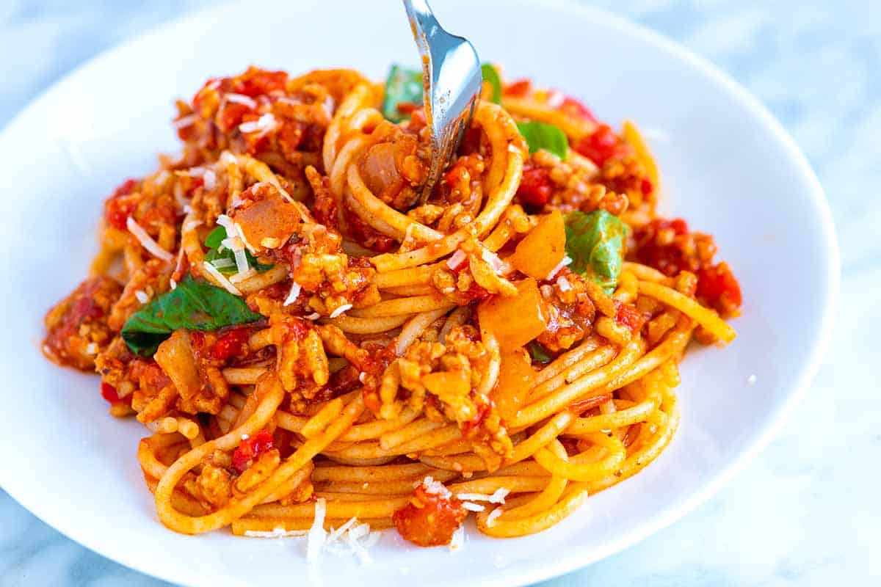

***Spaghetti Recipe***

## ***Ingedients***

***SPAGHETTI AND MEAT SAUCE***

***1 pound lean ground meat like beef, turkey, chicken or lamb***

***3 tablespoons olive oil***

***1 cup (130 grams) chopped onion***

***3 garlic cloves, minced (1 tablespoon)***

***2 tablespoons tomato paste***

***1/2 teaspoon dried oregano***

***Pinch crushed red pepper flakes***

***1 cup water, broth or dry red wine***

***1 (28-ounce) can crushed tomatoes***

***Salt and fresh ground black pepper***

***Handful fresh basil leaves, plus more for serving***

***12 ounces dried spaghetti or favorite pasta shape***

***1/2 cup shredded parmesan cheese***

***OPTIONAL INGREDIENTS, SEE NOTES***

***2 to 3 teaspoons fish sauce***

***3 to 4 anchovy fillets, minced with some of their oil or use anchovy paste***

***Pinch sugar***

***1 leftover rind from a wedge of parmesan***

## ***DIRECTIONS***

* ***MAKE SAUCE***
* ***Heat the oil in a large pot over medium-high heat (we use a Dutch oven). Add the meat and cook until browned, about 8 minutes. As the meat cooks, use a wooden spoon to break it up into smaller crumbles.  
  Add the onions and cook, stirring every once and a while, until softened, about 5 minutes.  
  Stir in the garlic, tomato paste, oregano, and red pepper flakes and cook, stirring continuously for about 1 minute.  
  Pour in the water and use a wooden spoon to scrape up any bits of meat or onion stuck to the bottom of the pot. Stir in the tomatoes, 3/4 teaspoon of salt, and a generous pinch of black pepper. Bring the sauce to a low simmer. Cook, uncovered, at a low simmer for 25 minutes. As it cooks, stir and taste the sauce a few times so you can adjust the seasoning accordingly (see notes for suggestions).***
  + ***COOK SPAGHETTI***
  + ***About 15 minutes before the sauce finishes cooking, bring a large pot of salted water to the boil, and then cook pasta according to package directions, but check for doneness a minute or two before the suggested cooking time.***
    - ***TO FINISH***

***Take the sauce off of the heat, and then stir in the basil. Toss in the cooked pasta, and then leave for a minute so that the pasta absorbs some of the sauce. Toss again, and then serve with parmesan sprinkled on top.***

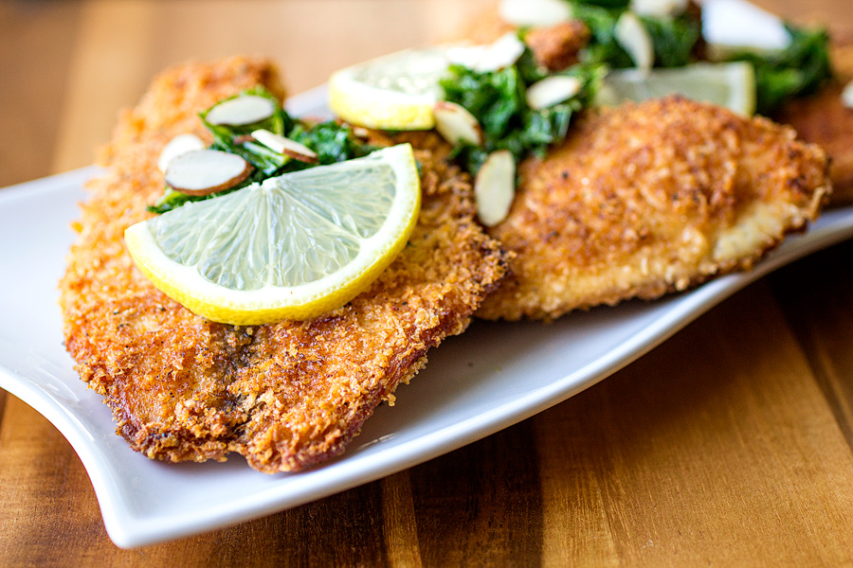

***Fried Fish Recipe 1***

### ***Ingredients***

* ***▢***
* ***2 thin fish fillets, around 150g/5 oz each, 1 cm / 2/5" thick, skin on or off (Note 1)***
* ***▢***
* ***Salt and pepper***
* ***▢***
* ***1/4 cup / 35g flour (plain/all purpose, wholemeal)***
* ***▢***
* ***1 tsp paprika , optional (Note 2)***
* ***▢***
* ***2 - 3 tbsp oil, enough to mostly thinly cover base (I use vegetable or canola)***

#### ***GARNISHES:***

* ***▢***
* ***Lemon wedges***
* ***▢***
* ***Finely chopped parsley or dill , for garnish, optional***

### ***Instructions***

1. ***Use scrunched up paper towels to pat the fish dry on both sides. This is especially important if you are using thawed frozen fish.***
2. ***Season the fish well on both sides with salt and pepper (key!).***
3. ***Mix the flour and paprika on a plate.***
4. ***Coat fish on both sides with flour, pressing down firmly so it adheres, but shake well to remove excess. (Note 2)***
5. ***Heat a heavy based skillet (normal or non stick) over medium high heat until you see wisps of smoke. Add oil and swirl to coat the pan - it will heat within seconds.***
6. ***Add fish - it should sizzle straight away. Shake the pan lightly to move the fish. Cook for 2 minutes until golden and crisp, pressing down gently, then flip. Cook the other side for 2 minutes until crisp then remove.***
7. ***If it's browning too quickly, just remove pan from the stove briefly. If it's stuck, don't move - it will release naturally once golden.***
8. ***Serve fish immediately with lemon wedges and garnished with dill or parsley, if using. It starts to lose crispiness after 5 minutes.***

***Fried Fish Recipe 2***

* ***1 egg***
* ***1 ½ cups beer***
* ***1 cup all-purpose flour***
* ***1 teaspoon garlic powder***
* ***½ teaspoon salt***
* ***½ teaspoon ground black pepper***
* ***1 pound cod fillets***
* ***2 cups crushed cornflake crumbs***
* ***1 teaspoon Cajun seasoning***
* ***1 quart oil for frying***

*Instructions Checklist*

* ***Step 1  
  In a medium bowl, beat together egg, beer, flour, garlic powder, salt, and pepper. Place cod in the bowl, and thoroughly coat with the mixture.***
* ***Step 2  
  In a separate medium bowl, mix the cornflake crumbs and Cajun seasoning. Dip the cod in the crumb mixture, and thoroughly coat all sides.***
* ***Step 3  
  In a large, heavy skillet or deep fryer, heat the oil to 365 degrees F (185 degrees C). Fry the fish until golden brown, and flesh is easily flaked with a fork.***

***Fried Fish Recipe 3***

*Ingredients:*

* *4 tilapia fillets*
* *Olive oil*
* *4 cloves garlic pressed through garlic press, divided use*
* *Salt*
* *¾ teaspoon paprika, divided use*
* *¼ teaspoon plus a pinch cracked black pepper, divided use*
* *2 teaspoons fresh lemon juice, divided use*
* *½ teaspoon grated lemon zest*
* *¼ cup plus 2 tablespoons flour*
* *2 eggs, whisked*
* *¾ cup panko breadcrumbs*
* *¼ cup finely grated parmesan cheese*
* *Vegetable oil, for pan frying (about ½ cup)*
* *4 cups (heaping) mustard greens, coarsely chopped and woody rib/stems removed*
* *¼ cup toasted, sliced almonds*
* *Lemon slices for garnish*

*Preparation:*

1. *Begin by gathering and prepping all of your ingredients according to the ingredient list above to have ready and organized for use.*
2. *Place the tilapia fillets onto a large platter, and add to them about 2 tablespoons of the olive oil, 2 cloves of the pressed garlic, a couple of good pinches of salt, about ½ teaspoon of the paprika, ¼ teaspoon of the cracked black pepper, 1 teaspoon of the lemon juice and the ½ teaspoon of lemon zest, and gently distribute these ingredients over the fillets to evenly coat each one. Marinate the fillets for at least 30 minutes, up to 4 hours, depending on how full-flavored you like them.*
3. *After marinating the fillets, prepare to dredge them: add the flour into a large, shallow bowl, the whisked eggs into another bowl, and combine the panko with the parmesan in a third large, shallow bowl, along with a pinch of salt, the remaining ¼ teaspoon paprika and the pinch of cracked black pepper.*
4. *Dip both sides of each fillet in the flour, then the whisked eggs, then the panko/parmesan mixture, and set the breaded fillets aside.*
5. *Next, place a large, non-stick skillet over medium-high heat, and add in the vegetable oil, roughly ½ cup. Allow the oil to heat up (you can test it by dropping a small crumb of the breading into it, and if it floats, sizzles and fries, it's hot enough to fry the fish), and once hot, add the fillets into the pan (working in batches, if necessary) pan frying the fillets for roughly 4 minutes for the first side, or until golden-brown in color, and roughly 3 minutes on the second side.*
6. *Once the fillets are fried, place them onto a wire rack paper to drain, keeping them warm while you prepare the mustard greens.*
7. *To prepare the mustard greens, place a large non-stick skillet over medium heat, and add in about 2 tablespoons of olive oil. Once the oil is hot, add in the remaining 2 cloves of pressed garlic, and as soon as the garlic becomes aromatic, turn the heat off from under the pan, and add in the mustard greens, gently tossing them in with the garlic-oil to coat allowing the greens to gently wilt and warm up.*
8. *Add in a good pinch of salt and the remaining 1 teaspoon of lemon juice, and toss to combine.*
9. *To serve, place the pan fried fish onto a serving platter, top with equal portions of the greens, and sprinkle over top about 1 tablespoon worth of the toasted, sliced almonds, and garnish with a semi-circle wedge of lemon. Serve with rice, roasted potatoes, or any favorite accompaniment.*

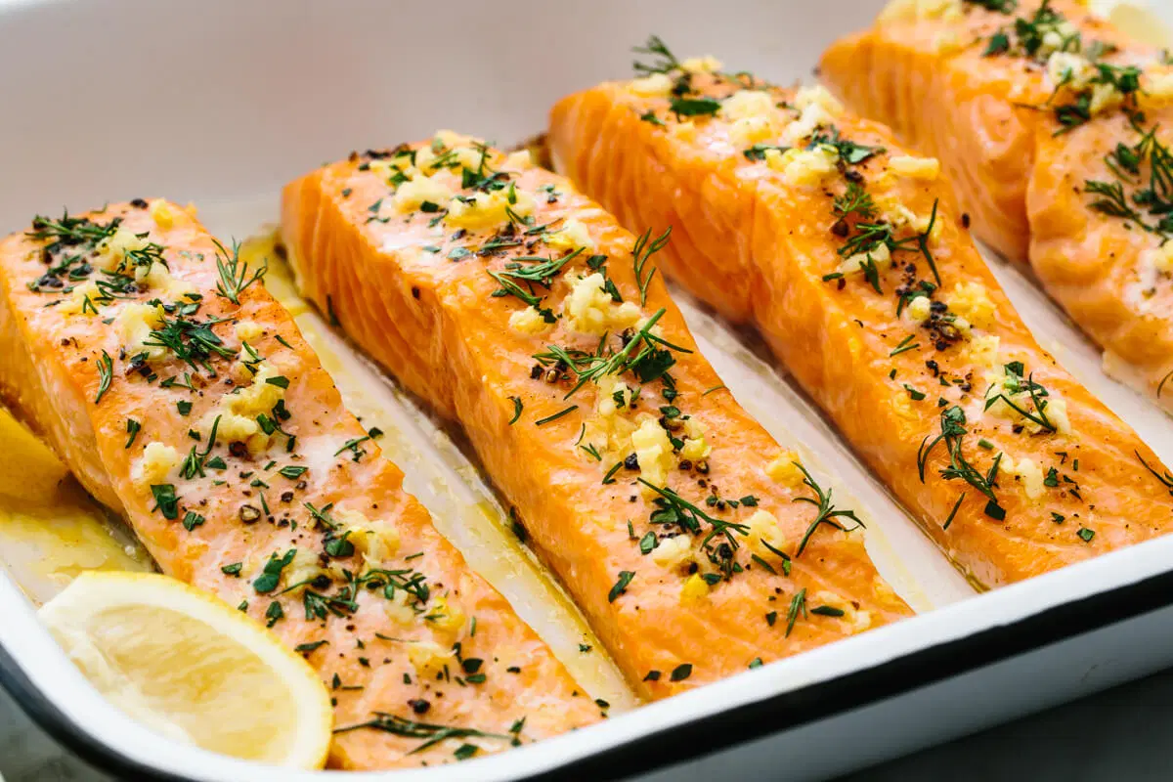

***Baked Salmon Recipe***

### ***Ingredients***

***12 ounce salmon fillet, cut into 4 pieces***

***Coarse-grained salt***

***Freshly ground black pepper***

### ***Directions***

1. ***Preheat the oven to 450 degrees F.***
2. ***Season salmon with salt and pepper. Place salmon, skin side down, on a non-stick baking sheet or in a non-stick pan with an oven-proof handle. Bake until salmon is cooked through, about 12 to 15 minutes.***

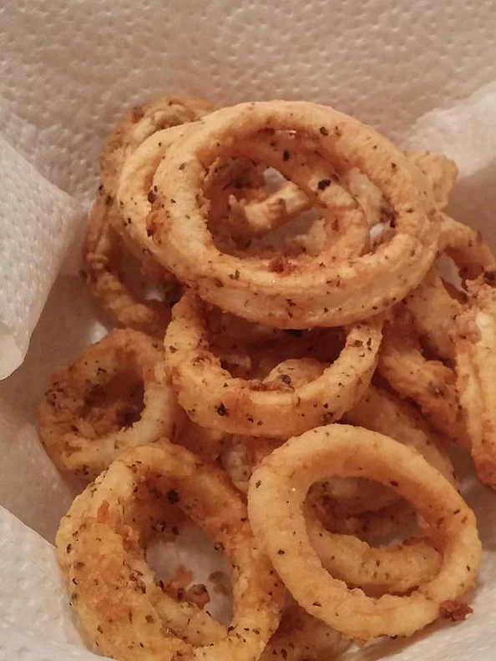

***Calamari Recipe***

## ***Ingredients***

***Ingredient Checklist***

* ***3 cups vegetable oil***
* ***¼ cup all-purpose flour***
* ***1 teaspoon salt***
* ***1 teaspoon dried oregano***
* ***½ teaspoon ground black pepper***
* ***12 squid, cleaned and sliced into rings***
* ***1 lemon - cut into wedges, for garnish***

*Instructions Checklist*

* ***Step 1  
  Preheat oil in a heavy, deep frying pan or pot. Oil should be heated to 365 degrees F (180 degrees C).***
* ***Step 2  
  In a medium size mixing bowl mix together flour, salt, oregano and black pepper. Dredge squid through flour and spice mixture.***
* ***Step 3  
  Place squid in oil for 2 to 3 minutes or until light brown. Beware of overcooking, squid will be tough if overcooked. Dry squid on paper towels. Serve with wedges of lemon.***

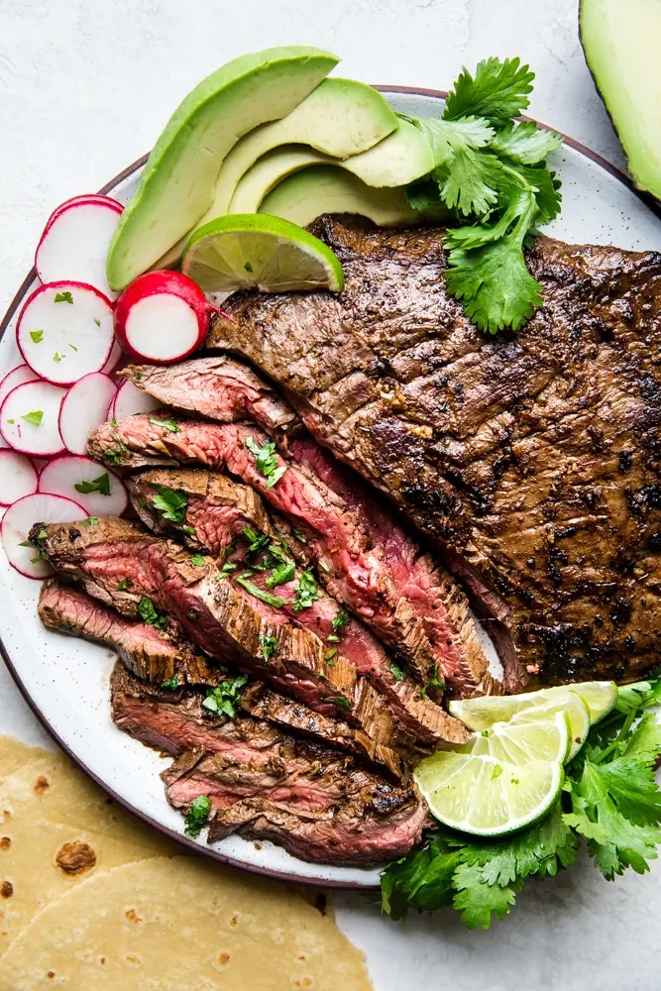

***Carne Asada Recipe 1***

### *Ingredients*

***Marinade:***

* ***1/3 cup extra virgin olive oil***
* ***1/4 cup soy sauce***
* ***2 tablespoons lime juice***
* ***2 tablespoons cider vinegar***
* ***2 tablespoons sugar***
* ***1 teaspoon freshly ground black pepper***
* ***1 teaspoon ground cumin***
* ***4 garlic cloves, minced***
* ***1 jalapeño chili pepper, seeded and minced***
* ***1/2 cup finely chopped fresh cilantro leaves and stems***

***Steak:***

* ***1 1/2 to 2 pounds flank or skirt steak***

***Fixings (optional):***

* ***Chopped avocado***
* ***Lime wedges***
* ***Corn or flour tortillas***
* ***Thinly sliced radishes***
* ***Thinly sliced lettuce***
* [***Pico de gallo salsa***](https://www.simplyrecipes.com/recipes/fresh_tomato_salsa/)

### *Method*

1. ***Marinate the steak:  
   Whisk to combine the olive oil, soy sauce, lime juice, vinegar, sugar, black pepper, and cumin in a large, non-reactive bowl or baking dish. Stir in the minced garlic, jalapeño, and cilantro.  
   Place the steak in the marinade and turn over a couple of times to coat thoroughly.  
   Cover in plastic wrap and refrigerate for 1 to 4 hours or overnight (if using flank steak marinate at least 3 hours).***
2. ***Preheat the grill:  
   Preheat your grill for high direct heat, with part of the grill reserved with fewer coals (or gas flame) for low, indirect heat. You'll know the grill is hot enough when you can hold your hand above the grill grates for no more than one second.  
   (You can also use a cast iron grill pan on high heat if cooking on the stovetop.)***
3. ***Sear the steak:  
   Remove the steak from the marinade. Lightly brush off most of the bits of cilantro and garlic (do not brush off the oil).  
   Place on the hot side of the grill. Grill the steak for a few minutes only, until well seared on one side (the browning and the searing makes for great flavor), then turn the steak over and sear on the other side.***
4. ***Move the steak to the cool side of the grill:  
   Once both sides are well seared, move the steak to the cool side of the grill, with any thicker end of the steak nearer to the hot side of the grill.  
   Test with a*** [***meat thermometer***](https://www.simplyrecipes.com/the_thermapen_instant_read_thermometer/) ***into the thickest part of the steak, or use your fingers (see*** [***The Finger Test to Check the Doneness of Meat***](https://www.simplyrecipes.com/recipes/the_finger_test_to_check_the_doneness_of_meat/)***). Pull the meat off the grill at 115°F to 120°F for rare, 125°F medium rare, 140°F for medium. The meat will continue to cook in its residual heat.  
   Note that lean flank steak is best cooked rare, while skirt steak can be cooked well without losing moisture or flavor because it has more fat marbling.***
5. ***Tent with foil and let rest:  
   Place the steak on a cutting board, tent with foil, and let rest for 10 minutes.***
6. ***Slice the steak across the grain:  
   Use a sharp, long bladed knife (a bread knife works great for slicing meat) to cut the meat. Notice the direction of the grain of the meat and cut perpendicular to the grain. Angle your knife so that your slices are wide and thin.***

***Carne Asada Recipe 2***

### *INGREDIENTS*

* ***2 pounds skirt steak trimmed of excess fat***

#### *Carne Asada Marinade*

* ***1 jalapeño seeded and minced***
* ***4 cloves garlic minced***
* ***½ cup fresh cilantro leaves chopped***
* ***juice of 1 orange***
* ***juice of 1 lime***
* ***juice of 1 lemon***
* ***2 tablespoons apple cider vinegar***
* ***⅓ cup olive oil***
* ***1 teaspoon ground cumin***
* ***1 teaspoon kosher salt***
* ***¼ teaspoon freshly ground black pepper***

### *INSTRUCTIONS*

### 

1. ***In a large glass baking dish whisk together Carne Asada marinade ingredients (jalapeño through black pepper) until combined. Add skirt steak in a single layer, turning to coat with marinade. Cover and refrigerate for at least 1 hour, but no longer than 8 hours (longer will begin to break down the meat).***
2. ***When you're ready to grill: preheat an outdoor grill to medium-high heat. Grill steaks for 7 to 10 minutes per side, turning once for medium-rare. Remove steaks and allow to rest for 5 minutes.***
3. ***Slice thinly across the grain and serve.***

***Carne Asada Recipe 3***

## ***Ingredients***

* ***2 lbs. Flank Steak***
* ***¼ cup fresh lime juice***
* ***½ cup fresh orange juice, about 2 oranges***
* ***½ cup olive oil***
* ***2 Tbsp. red wine vinegar***
* ***2 tsp. salt***
* ***1 tsp. freshly ground black pepper***
* ***1 tsp. ground cumin***
* ***1 tsp. oregano***
* ***4 garlic cloves, minced***

## ***Preparation***

1. ***In a medium-sized bowl, whisk together lime juice, orange juice, olive oil, vinegar, salt, pepper, cumin, oregano and garlic. Pour into a 9×12-inch baking dish.***
2. ***Add flank steak. Turn to coat both sides in marinade. Cover with plastic wrap and place in fridge to marinate for up to 4 hours. Remove meat and discard marinade.***
3. ***Preheat gas or charcoal grill to 400°F.***
4. ***Place steaks on oiled grates and grill steaks 8-10 minutes on one side or until moisture starts to pool on the top and beef releases easily from grates with tongs. Flip once, grilling on the other side for 8-10 minutes or until internal temperature reaches 145°F with meat thermometer inserted into the thickest part of the steak.***
5. ***Transfer steaks to a platter and let rest for 5-10 minutes before slicing against the grain.***

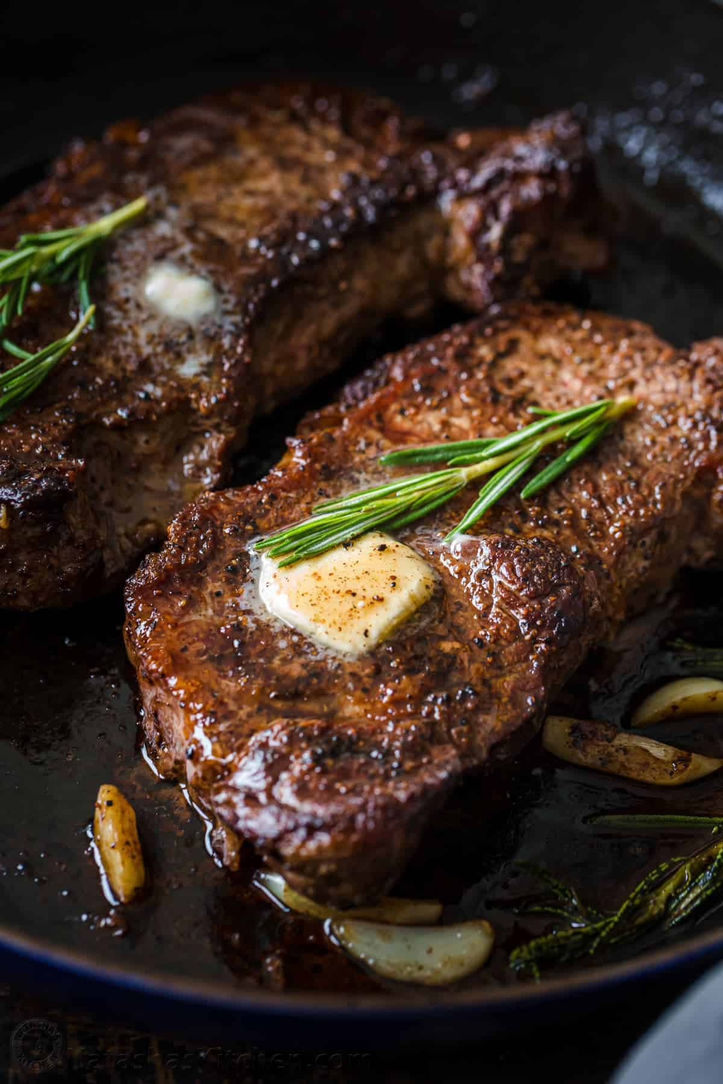

***Steak Recipe***

### ***Ingredients***

* ***2 lbs New York Strip Steaks (2 steaks), or Ribeye or Top Sirloin Steaks (1 lb each steak, 1 1/4” thick)***
* ***1/2 Tbsp vegetable oil, or any high heat cooking oil like canola or extra light olive oil***
* ***1 1/2 tsp sea salt***
* ***1 tsp black pepper, freshly ground***
* ***2 Tbsp unsalted butter***
* ***2 cloves garlic, peeled and quartered***
* ***1 sprig fresh rosemary***

### ***Instructions***

1. ***Thoroughly pat steak dry with paper towels. Just before cooking, generously season with 1 1/2 tsp salt and 1 tsp black pepper***
2. ***Heat the cast iron pan until hot then add 1/2 Tbsp oil over medium-high heat, swirling to coat. Once the oil is very hot, add steaks to the skillet. Sear the steaks on the first side for 4 minutes until a brown crust has formed then flip and cook another 3-4 minutes. Using tongs, turn the steak on its sides to render the white fat and sear the edges (1-minute per edge).***
3. ***Reduce heat to medium and immediately add 2 Tbsp butter, quartered garlic cloves and rosemary to the pan. Spoon the butter sauce over the steak, tilting the pan to get butter on your spoon. Continue spooning the sauce over the steak for a minute or until the steak is about 5-10 degrees from your desired doneness (the temperature will continue to rise another 5-10 degrees while steaks rest).***
4. ***Transfer steak to a cutting board, loosely cover and rest 10 minutes before slicing into 1/2" strips to serve. Spoon extra butter sauce over sliced steak to serve.***

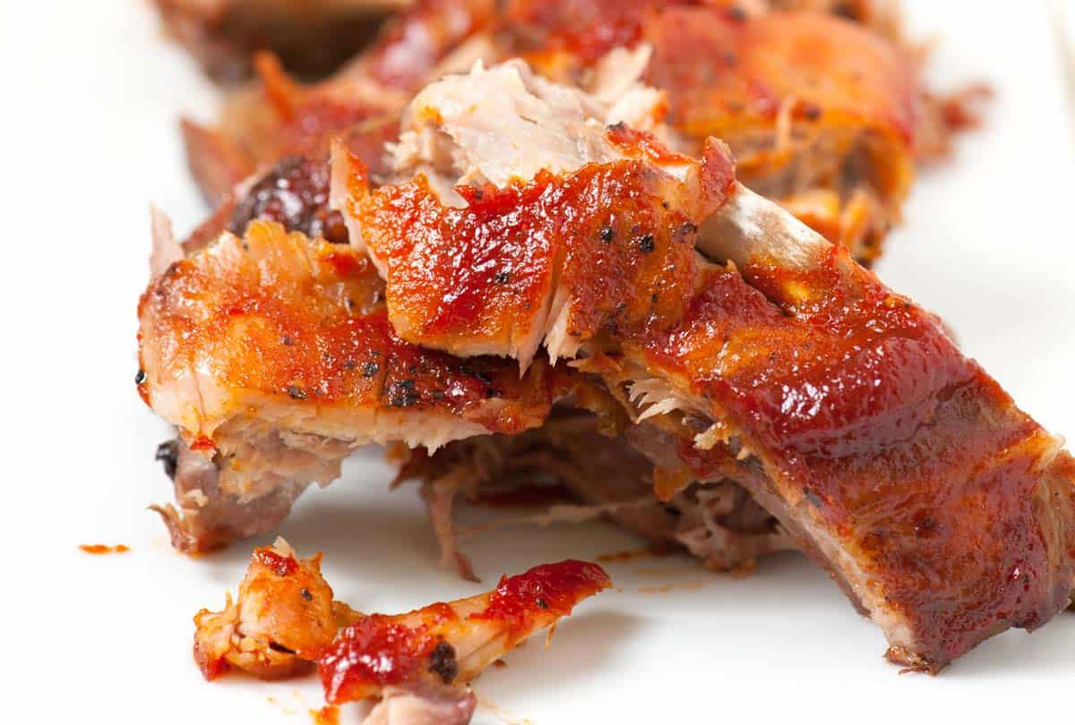

***Oven Baked Ribs Recipe***

## ***Ingredients***

***RIBS***

***2 to 2 1/2 pounds baby back pork ribs***

***Salt and black pepper***

***SWEET AND SPICY BARBECUE SAUCE***

***1 tablespoon olive oil***

***1/4 cup finely diced onion***

***1/2 teaspoon ground cumin***

***1/2 cup ketchup***

***1 tablespoon hot chili sauce (suggestion Sriracha)***

***2 tablespoons light brown sugar***

***1 tablespoon apple cider vinegar***

***Salt and ground pepper, to taste***

## ***DIRECTIONS***

* ***PREPARE RIBS***
* ***Heat oven to 275° Fahrenheit (135C).  
  If the ribs still have the thin membrane covering the back of the rack, remove it. See how in the notes section below.  
  Season both sides of the ribs with a generous amount of salt and pepper. If you are using a spice rub, add season the ribs with it now. Place the ribs, meat-side up, into a large roasting pan or rimmed baking sheet. (It may be necessary to cut the ribs in half for them to fit into the pan).  
  Cover the pan or baking sheet tightly with aluminum foil, and then bake until the meat falls easily from the bones, 2 ½ to 3 ½ hours. We like to check the ribs after 2 hours to see how they are progressing. The ribs are done when the meat is cooked through and tender.***
  + ***MAKE BARBECUE SAUCE***
  + ***While the ribs bake, make the barbecue sauce. Heat the olive oil in a saucepan over medium heat.  
    Add the onions and cook until soft and translucent, 5 to 8 minutes. Stir in the cumin and cook for an additional 30 seconds.  
    Add the ketchup, hot chili sauce, brown sugar, and apple cider vinegar. Stir to combine, season with salt then cook for 2 minutes. Set aside in preparation for the ribs to finish roasting.***
    - ***TO FINISH***

***Remove the ribs from the oven, discard the aluminum foil and generously brush both sides with barbecue sauce.  
Optional: Move an oven rack near the top of the oven. Turn broiler to high and broil the ribs for 3-4 minutes, just until the barbecue sauce begins to caramelize. (Keep a close eye on the ribs while they broil so the sauce does not burn.)***